PROJECT FALCON-01
Design and Development of a Solar-Powered Smart Coastal Observation Buoy for Real-Time Coastal Monitoring and Pressure-Based Wave-Height Estimation
V3.4 — CLEAR DIAGRAMS UPDATED
Undergraduate Thesis Documentation
26 August 2026

Executive Summary
Project FALCON-01 is a low-cost, modular, solar-powered smart coastal observation buoy designed for near-real-time local monitoring. An ESP32 acquires pressure, position, wind, environmental, power, system-health, and security data. The ESP32 sends validated telemetry through USB serial/UART to an Orange Pi Zero 3, which stores records locally, exposes a REST API, and serves a responsive browser.
The Phase 1 study uses a Blue Robotics Bar02 or compatible waterproof pressure sensor as the primary wave input. The device directly measures underwater pressure variation. Software preserves raw pressure, filters noise, establishes a documented baseline, and converts the dynamic pressure component into an estimated wave-height value. The project therefore uses the wording pressure-based estimated wave height and does not claim that the pressure sensor directly measures laboratory-grade wave height.
The buoy uses passive mooring with adequate line scope for tides and normal wave motion. Security is provided by persistent GPS geofence monitoring, a generic vibration/tamper input, an enclosure reed or limit switch, and a buzzer. Artificial intelligence is optional and supporting; all core monitoring, logging, security, and visualization functions operate without it.

1. Project Background
The Philippines has extensive coastlines that support fisheries, transport, tourism, education, environmental research, and community livelihoods. Localized coastal conditions can differ from broader forecasts, yet continuous observation equipment may be difficult for small schools and communities to acquire and maintain. Commercial oceanographic buoys provide professional measurements but can involve high cost, proprietary systems, specialized servicing, and infrastructure beyond the resources of an undergraduate project.
Affordable microcontrollers, single-board computers, solar components, and open-source software make it possible to investigate a smaller local-first platform. FALCON combines deterministic sensor acquisition on an ESP32 with local storage and visualization on an Orange Pi. Its purpose is educational and research-oriented monitoring, not replacement of professional oceanographic instruments or official agencies.

2. Statement of the Problem
Many low-cost monitoring prototypes demonstrate sensors and dashboards but do not provide a complete serviceable platform that combines traceable pressure-based wave estimation, local environmental data, power autonomy, local data retention, and basic anti-theft/tamper awareness. The study asks whether these functions can be integrated and evaluated within an affordable undergraduate prototype while clearly distinguishing measured, estimated, simulated, stale, and uncalibrated data.
1. How can a low-cost solar-powered buoy acquire and retain near-real-time coastal measurements using an ESP32 and local Orange Pi edge computer?
2. How accurately and repeatably can calibrated underwater-pressure variation be processed into an estimated wave-height signal under controlled conditions?
3. How reliably can GPS geofence, vibration/tamper, and enclosure-access rules detect persistent security events without being triggered by normal wave movement?
4. How clearly can a simplified four-page local dashboard communicate wave, environment, GPS, power, security, health, and alert information with minimal navigation for non-technical users?
5. How does the prototype perform in sensor accuracy, communication reliability, dashboard usability, energy use, data retention, and system recovery?
6. If optional AI is evaluated, does it improve a documented baseline without interrupting the core monitoring system?

3. Research Gap and Proposed Novelty
Existing low-cost IoT studies frequently emphasize acquisition and display, while professional platforms emphasize calibrated accuracy at substantially greater cost. A practical gap remains for an open, modular, locally operated educational prototype that integrates pressure-based wave estimation, environmental context, solar power, local logging, serviceability, and simple security monitoring for controlled Philippine coastal trials.
FALCON does not claim to invent pressure sensing, GPS geofencing, or wave science. Its proposed novelty is the transparent integration and evaluation of these established technologies in an affordable local-first platform. The study will report limitations, calibration state, and actual test evidence instead of presenting planned hardware or simulator output as completed field performance.

4. Objectives

4.1 General Objective
To design, develop, and evaluate a low-cost solar-powered smart coastal observation buoy that provides local real-time coastal monitoring and pressure-based estimated wave height through an ESP32–Orange Pi architecture and responsive web dashboard.

4.2 Specific Objectives
1. Integrate pressure, GPS, wind, environmental, power, system-health, and security channels using documented interfaces and calibration states.
2. Develop a traceable pipeline that retains raw and filtered pressure, baseline, optional depth, estimated wave height, validity, timestamp, and calibration metadata.
3. Implement persistent/debounced geofence, tamper, and enclosure security rules with SECURE, WARNING, ALERT, and DISARMED states.
4. Implement local serial ingestion, SQLite storage, REST API, logs, alerts, and automatic service recovery on the Orange Pi.
5. Develop a responsive dashboard with Overview, Buoy Motion, Sensors, and Logs & Alerts as four primary navigation pages while clearly labeling Buoy Motion as an optional visualization rather than a required IMU measurement.
6. Evaluate subsystem accuracy, reliability, latency, false alerts, usability, power consumption, and controlled deployment readiness.

5. Scope and Delimitations
Phase 1 covers a single near-shore prototype, passive single-anchor mooring, local ESP32 acquisition, USB/UART transfer, Orange Pi local processing, pressure-based estimated wave height, core/supporting environmental readings, power monitoring, basic security, local logging, and a browser dashboard. Physical models marked TBD require selection before final wiring or procurement.
The study does not provide official weather, storm, typhoon, tsunami, navigation, or emergency warnings. It does not claim laboratory-grade water-quality analysis, professional oceanographic accuracy, autonomous navigation, satellite communication, camera AI, or multi-buoy operation. Internet connectivity is optional. AI wave prediction is an optional extension and not a required study outcome.

6. System Architecture

Figure 1 summarizes the current adviser-revised architecture. The core monitoring path remains operational without optional AI. Sensor values are validated and clearly labeled by source and calibration state before display.

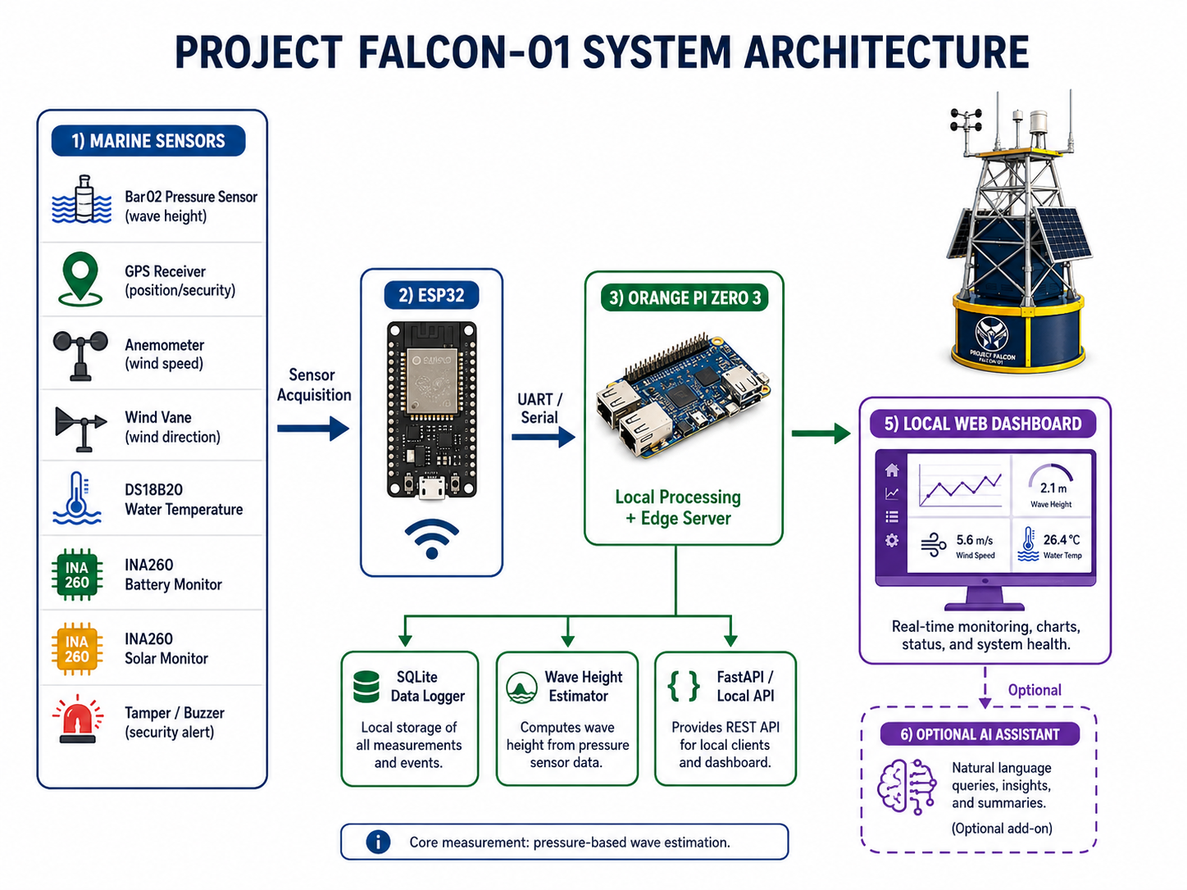

Figure 1. Detailed Project FALCON-01 system architecture and local-first data flow.
Layer | Primary responsibility | Failure behavior
Sensors and interfaces | Produce raw pressure, GPS, wind, environment, power, and security signals | Invalid/unavailable values are reported, not replaced by zero
ESP32 | Acquire, timestamp, validate, debounce, apply calibration, frame serial telemetry | Continues acquisition if Orange Pi is unavailable
Orange Pi Zero 3 | Ingest, filter, estimate waves, apply geofence rules, store, serve API/dashboard | Restarts services and preserves local records where possible
Dashboard | Display current state, optional pressure-driven motion visualization, grouped sensors, logs, and alerts | Shows OFFLINE/STALE instead of fabricated data
Optional AI | Experimental short-term prediction after baseline validation | May fail or be disabled without affecting monitoring

7. Hardware Components
Group | Component | Purpose and status
Core | Bar02 or compatible pressure sensor | Raw pressure and calibrated estimated wave height; selected family
Core | GPS receiver | Position, time, fix quality, geofence; exact model TBD
Core | Wind speed/direction | Local wind context; exact models TBD
Supporting | Sealed DS18B20 | Water temperature; reference comparison required
Health | Battery, solar, enclosure temperature | Energy and electronics health; exact interfaces verified before fabrication
Security | GPS geofence, tamper input, enclosure switch, buzzer | Debounced/persistent anti-theft awareness; exact hardware TBD where stated
Controller | ESP32 DevKit | Deterministic sensor acquisition and serial telemetry
Edge | Orange Pi Zero 3 (4 GB) | Local database, API, dashboard, optional AI
Exact datasheets, logic voltages, connector pinouts, footprints, current requirements, and environmental ratings must be verified before final PCB release.

7.1 Water Temperature Monitoring
FALCON includes a sealed DS18B20 supporting sensor that reports water temperature in degrees Celsius. This channel provides environmental context and does not constitute laboratory-grade water-quality analysis.
Channel | Required output | Validity and calibration rule
Sealed DS18B20 | Water temperature (°C), timestamp, validity, and freshness | Compare with a traceable reference thermometer; report OFFLINE or STALE when invalid
The dashboard displays this channel under Water. Exact model identification, sampling, freshness, validity, and reference-comparison status remain available in expanded technical details.

8. Pressure-Based Wave Estimation Method

The pressure-based wave method is treated as an estimation and validation pipeline rather than a direct wave-height measurement. The following flow defines the required processing and evidence path.

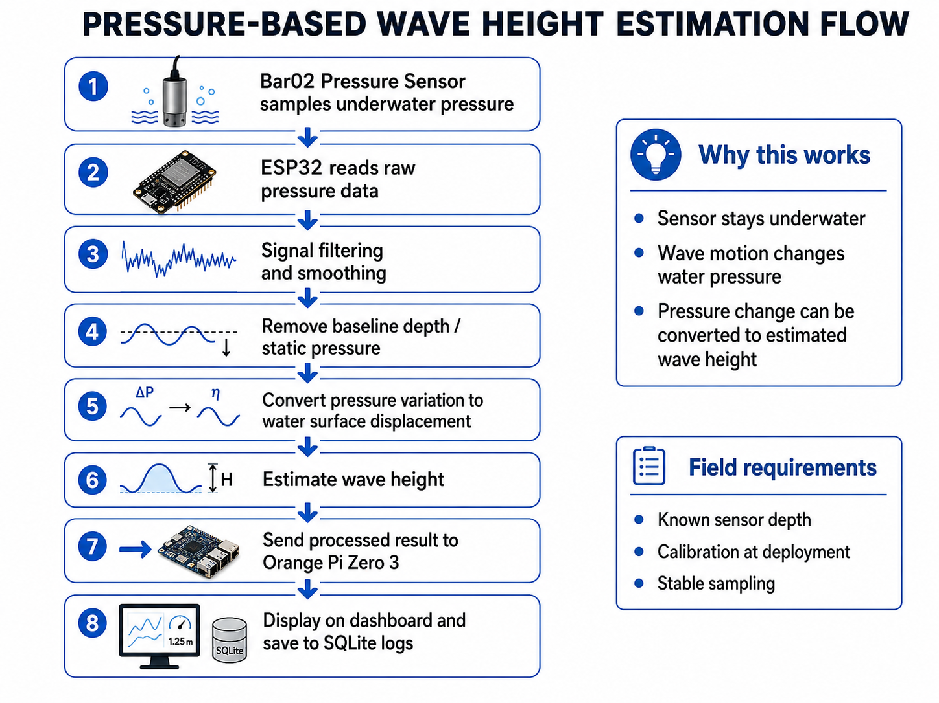

Figure 2. Detailed pressure-based wave-height estimation and reference-validation flow.
1. Read timestamped raw underwater pressure in documented engineering units.
2. Reject missing, out-of-range, disconnected, or stale samples while retaining diagnostic reasons.
3. Apply a documented low-pass/band-pass or equivalent filter selected through controlled data analysis.
4. Establish a pressure baseline at a measured installation depth and record temperature and calibration conditions.
5. Isolate the dynamic pressure variation associated with water-surface motion.
6. Apply the documented hydrostatic/dynamic conversion and calibration coefficient to estimate wave height.
7. Report estimated wave height, quality/validity, timestamp, source, baseline, and calibration state.
8. Compare results with a documented reference method and report MAE, RMSE, bias, repeatability, and limitations.
Until reference testing is complete, displayed values must say ESTIMATED and CALIBRATION REQUIRED. Simulator values must additionally say SIMULATED.

9. Security and Tamper Method

Security is implemented as a persistent state machine so ordinary wave motion or single transient events do not immediately trigger the buzzer.

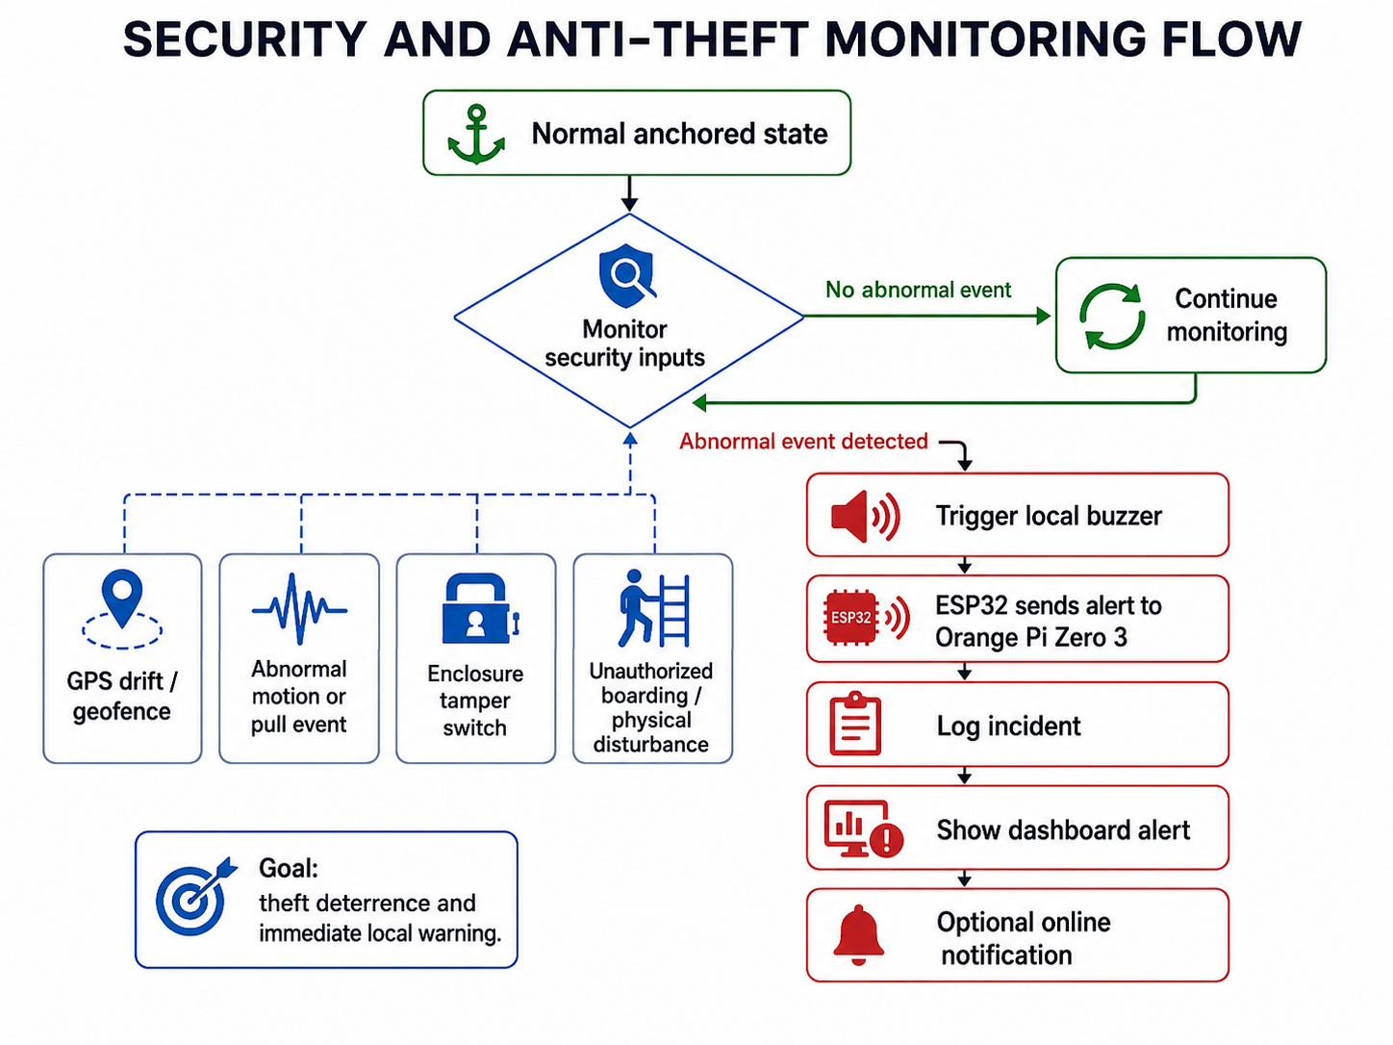

Figure 3. Detailed security and anti-theft monitoring flow.
The deployment reference coordinate and geofence radius are configuration values. A position outside the radius enters WARNING while the system evaluates fix quality and persistence. A sustained violation becomes ALERT. Vibration/tamper and enclosure-switch inputs use electrical filtering where required plus firmware debounce/persistence. Ordinary wave movement does not constitute tampering. Authorized maintenance uses DISARMED and creates an event record.
State | Meaning | Dashboard response
SECURE | Inside geofence; enclosure closed; no persistent tamper | Normal status
WARNING | Transient/uncertain event under persistence evaluation | Review message
ALERT | Persistent geofence/tamper/enclosure event | Prominent alert and buzzer rule
DISARMED | Authorized maintenance mode | Logged maintenance indicator

10. Software, API, and Data
The ESP32 publishes versioned newline-delimited JSON through USB serial/UART. The Orange Pi validates frames, stores the original payload in SQLite, calculates current derived state, persists alerts/events, and serves the dashboard. The grouped API contains system, wave, environment, GPS, power, security, health, assistant, and alerts sections. Legacy routes remain temporarily available for backward compatibility.
• LIVE — connected physical source.
• SIMULATED — presentation simulator.
• ESTIMATED — derived value rather than direct measurement.
• CALIBRATION REQUIRED — no completed reference calibration.
• STALE — update age exceeds the configured limit.
• OFFLINE — source unavailable.
• OPTIONAL — nonessential feature whose failure cannot stop monitoring.

11. Dashboard Design

The operator interface uses four primary navigation pages. Detailed diagnostics remain available through expandable views rather than one card per physical sensor.

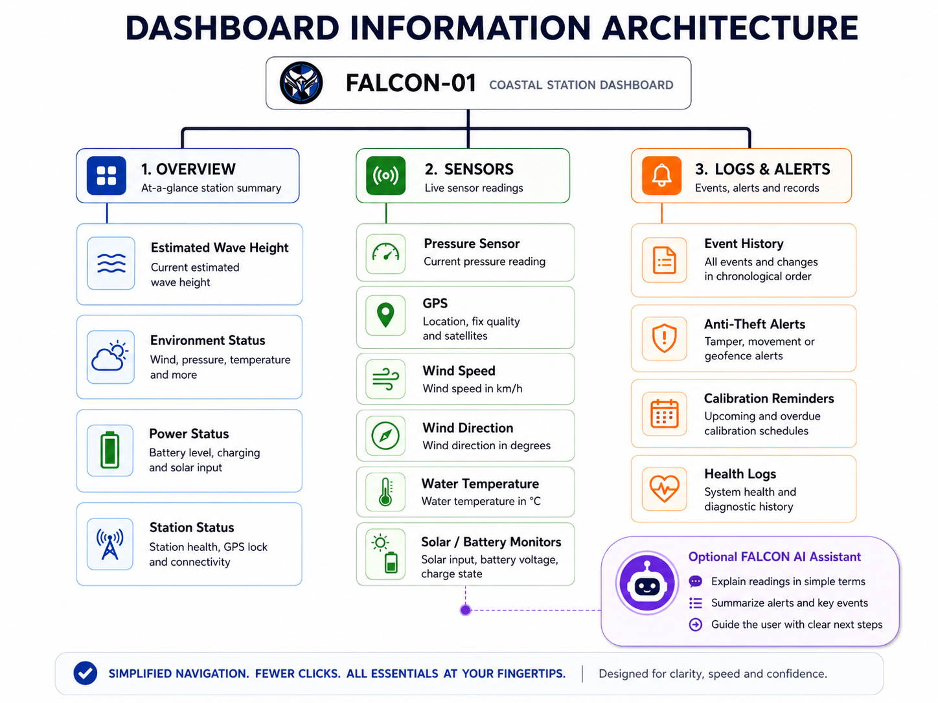

Figure 4. Simplified dashboard information architecture with grouped monitoring views and optional FALCON AI Assistant.
1. Overview: one large estimated-wave chart plus one Station Status summary for wind, pressure, GPS security, battery, solar, and water/enclosure temperature; optional AI is absent from the default operator view.
2. Buoy Motion: an optional 3D visualization whose water-surface amplitude, heave, and tilt are generated from pressure-based estimated wave height. GPS supplies heading context only; no IMU, roll, or pitch sensor input is used. Current Data uses the received estimate; Calm, Moderate, Rough, and Pressure Offline are clearly labeled local presentation presets that never modify stored or live telemetry. Current Data uses the received estimate; Calm, Moderate, Rough, and Pressure Offline are clearly labeled local presentation presets that never modify stored or live telemetry. Current Data uses the received estimate; Calm, Moderate, Rough, and Pressure Offline are clearly labeled local presentation presets that never modify stored or live telemetry.
3. Sensors: six grouped user-facing cards—Wave & Pressure, GPS & Security, Wind, Water, Power, and System. Technical details such as exact sensor model, sampling rate, calibration state, signal quality, and update age remain available through expandable details.
4. Logs & Alerts: current warnings, security/calibration/operator events, persisted telemetry, acknowledgement, search, and export.
Settings is a compact header icon. Optional predictive AI is hidden from the default operator view. The FALCON Assistant design and animation files are preserved for future review, but the assistant is currently disabled and not displayed in the operator dashboard. If re-enabled, it shall remain optional, rule-based, concise, and independent of safety-critical monitoring.

12. Testing and Evaluation Plan
Test area | Evidence and metrics
Sensors | Reference comparison, range, repeatability, invalid/disconnect behavior
Wave estimate | Known reference, MAE, RMSE, bias, repeatability, calibration record
Security | Geofence accuracy, persistence, false positives/negatives, tamper/enclosure tests
Communication | Packet loss, latency, stale detection, reconnect and restart recovery
Storage/API | Retention, timestamp integrity, schema tests, export verification
Power | Normal/peak current, conversion efficiency, autonomy, charge recovery, brownout
Dashboard | Desktop/mobile responsiveness, readability, task completion, label comprehension
Mechanical | Buoyancy, stability, water ingress, corrosion controls, mooring scope and retrieval
Optional AI | Separate baseline comparison and held-out data; no core-system dependency

13. Risk, Ethics, and Safety
Marine deployment requires permission, site-risk review, electrical protection, waterproofing, safe battery handling, retrieval planning, and weather limits. GPS data and future camera features require privacy controls. The dashboard must state that FALCON is a research prototype and does not replace PAGASA, coast guard instructions, navigation equipment, or emergency-warning systems.

14. Current Implementation and Limitations
The repository currently includes the ESP32 firmware shell, diagnostic portal, versioned serial frame, Python simulator/edge service, SQLite storage, deterministic alerts, grouped API, four-page dashboard, optional pressure-driven motion visualization, saved but disabled assistant assets, and optional presentation prediction. The software build and automated tests demonstrate implementation behavior only. They do not prove physical sensor accuracy or coastal readiness.
Physical pressure calibration, exact supporting/security part selection, final PCB/wiring release, Orange Pi installation, waterproofing, power autonomy, and controlled field trials remain pending. These limitations must remain visible in presentations, results, and conclusions.

15. Expected Output and Beneficiaries
The expected output is a documented, serviceable research prototype with traceable coastal readings, pressure-based estimated wave height, local records, security awareness, and a usable dashboard. Potential beneficiaries include students, researchers, educational institutions, coastal communities, and local organizations seeking an accessible platform for controlled observation and future study. Operational adoption requires further validation and coordination with competent authorities.

16. Development Roadmap
1. Approve exact component models and datasheets.
2. Freeze the adviser-approved electrical interfaces and revised PCB.
3. Bench-integrate Bar02, GPS, wind, DS18B20, health, and security channels.
4. Complete pressure/environment/security calibration and controlled reference tests.
5. Install and harden Orange Pi automatic services.
6. Complete enclosure, solar, mooring, and safe controlled water trials.
7. Analyze results and revise claims based on evidence.
8. Evaluate optional AI only if sufficient calibrated data and time remain.

17. Documentation Status
This V3.3 implementation-aligned document supersedes conflicting V2 and earlier V3 descriptions. The repository master context is docs/PROJECT_CONTEXT.md v6.1. Older CAD, Wokwi, motion, IMU, forecast, and PCB records may remain for historical traceability but are not the current required Phase 1 baseline unless revised and explicitly approved. Sections 22–27 and Figures 1–6 are part of the current documentation baseline and must remain consistent with docs/PROJECT_CONTEXT.md and the implemented repository. The physical and visual prototype is under redesign. Old CAD dimensions, component placement, solar arrangement, cooling geometry, and renders are historical references until adviser approval.

18. Pressure Sensor Installation and Reference Validation
Wave-height accuracy shall be established through comparison with an independent reference method during controlled testing. The reference may be a calibrated staff gauge/video method or another suitable reference instrument. Reference measurements must be time-aligned with the pressure data. The study will report error metrics and limitations rather than assume that pressure conversion alone is accurate.
The exact installation depth is not frozen in this document. It must be selected from the final buoy geometry, expected waterline, sensor operating range, wave conditions, and controlled test results. The installation record shall document the vertical distance from the normal waterline to the pressure-sensing element, orientation, mounting bracket, cable routing, and baseline conditions.
The pressure sensor shall be rigidly mounted below the normal waterline at a known submerged depth on a protected fixed bracket or lower structural member. It shall not hang freely from the mooring chain or rope because uncontrolled sensor movement would add measurement noise and make installation depth uncertain.

19. Simplified Operator Interface and Sensor Grouping
The Sensors page does not display one card per physical device. Individual devices are grouped into six user-facing categories: (1) Wave & Pressure, (2) GPS & Security, (3) Wind, (4) Water, (5) Power, and (6) System. Expanded details preserve the underlying engineering information such as exact sensor model, sample rate, signal quality, calibration state, source, and update age.
The default operator interface is intentionally simplified for quick use by non-technical and older users. The four navigation pages are Overview, Buoy Motion, Sensors, and Logs & Alerts; Buoy Motion is explicitly optional visualization. Important information should be understandable with minimal clicking, large readable labels, high contrast, and clear status colors.
The FALCON Assistant concept, mascot, and animation files are retained for possible future use, but the assistant is currently hidden from the dashboard while its final operator design is reviewed. If approved and re-enabled, it may translate existing validated system states into short explanations; it shall not create independent safety decisions.

20. Literature Basis for Pressure-Based Wave Estimation
The pressure-based method is supported by established wave-measurement literature. Bishop and Donelan (1987) showed that subsurface pressure measurements can be converted into wave information while emphasizing that pressure attenuation, sensor depth, and wave frequency require correction. Bonneton et al. (2018) further demonstrated reconstruction of free-surface elevation from subsurface pressure using a depth-aware nonlinear method. Ardhuin et al. (2019) emphasized that platform response, sensor characteristics, sampling, and processing affect reported sea-state estimates.
For Project FALCON, these studies justify using underwater pressure as the primary wave input while also requiring a documented installation depth, calibration, signal processing, and reference comparison. The thesis therefore reports pressure-based estimated wave height rather than claiming direct professional-grade wave-height measurement.

21. Reference Literature Added for the Revised Wave Method
Bonneton, P., Lannes, D., Martins, K., & Michallet, H. (2018). A nonlinear weakly dispersive method for recovering the elevation of irrotational surface waves from pressure measurements. Coastal Engineering, 138, 1–8. https://doi.org/10.1016/j.coastaleng.2018.04.005
Bishop, C. T., & Donelan, M. A. (1987). Measuring waves with pressure transducers. Coastal Engineering, 11(4), 309–328. https://doi.org/10.1016/0378-3839(87)90031-7
Ardhuin, F., Stopa, J. E., Chapron, B., Collard, F., Husson, R., Jensen, R. E., Johannessen, J., Mouche, A., Passaro, M., Quartly, G. D., Swail, V., & Young, I. R. (2019). Observing sea states. Frontiers in Marine Science, 6, Article 124. https://doi.org/10.3389/fmars.2019.00124

22. Power Architecture and Energy Flow
The power subsystem is treated as a measured engineering subsystem. Final panel rating, MPPT model, battery capacity, converter ratings, fuse values, and wire gauges must be frozen only after the component register and measured daily energy budget are completed.
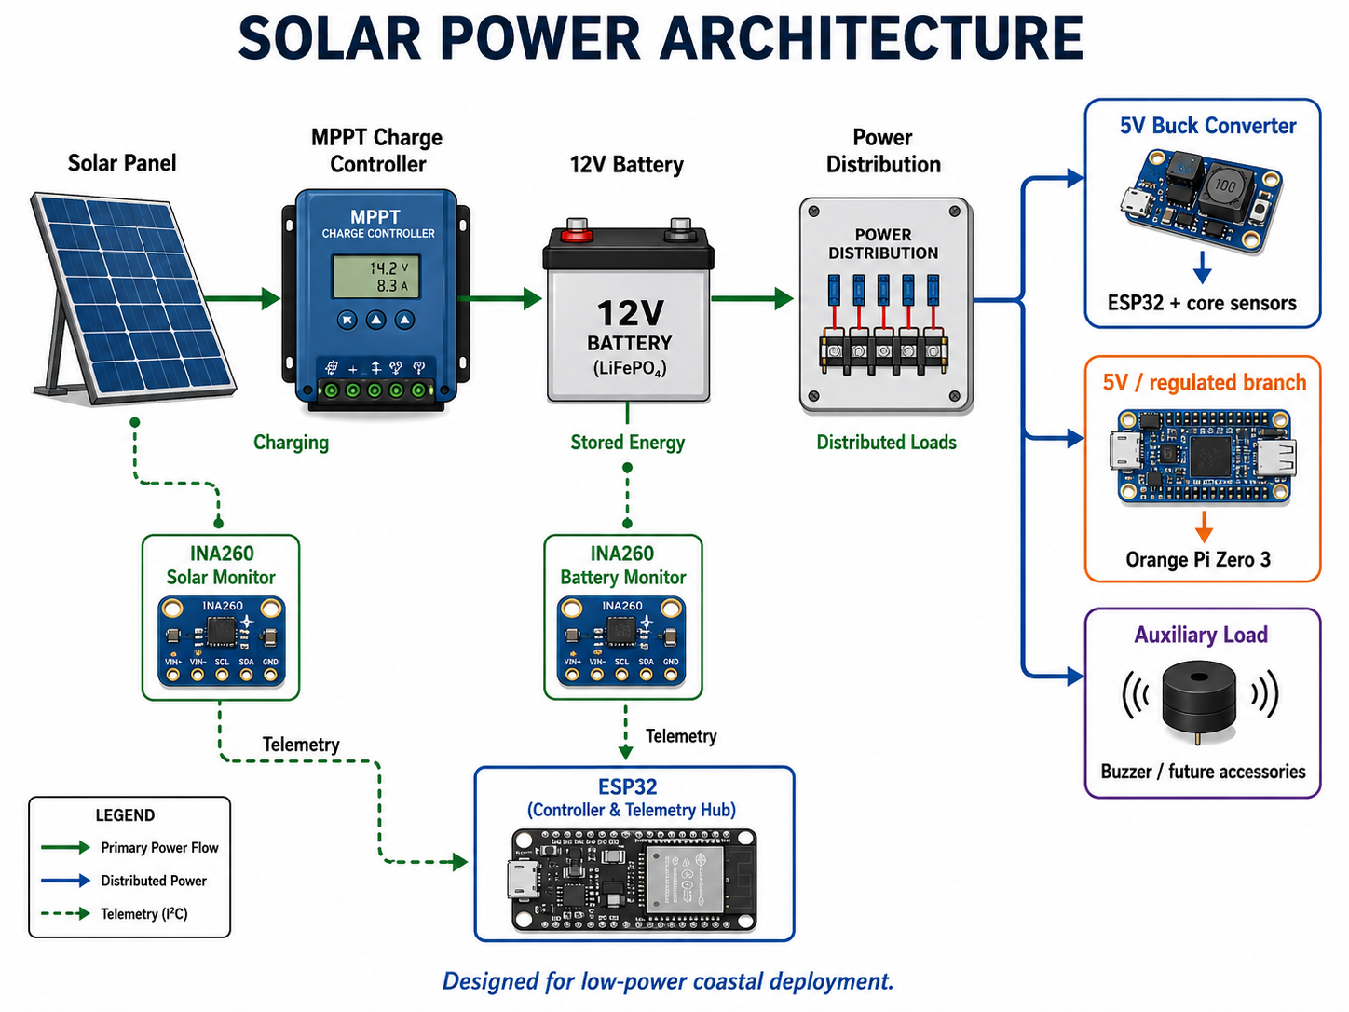

22.1 Provisional Electronics Consumption
The following values are design envelopes and planning assumptions, not measured continuous consumption. Final values shall be replaced by a 24-hour current log covering Orange Pi startup, Wi-Fi activity, storage writes, sensor sampling, fan startup, and idle operation.
Load | Preliminary electrical basis | Documentation status
Orange Pi Zero 3, storage, and Wi-Fi | Regulated 5 V / 3 A supply envelope (15 W maximum available, not assumed average draw) | Measure startup peak, idle, Wi-Fi, and database-write current
ESP32 and complete sensor carrier | Separate regulated 5 V / 2 A branch envelope (10 W maximum available) | Measure ESP32 plus every installed sensor; do not use the envelope as average consumption
Two optional enclosure fans | 2 × 5 V × 0.15 A = 1.5 W maximum | Include only if the selected fans are installed and thermally required
Pressure, GPS, wind, water, power, and security sensors | Included in the ESP32/sensor branch | Record individual idle/active current from exact purchased datasheets and bench measurements
DC conversion and charging losses | Included through conservative system-efficiency assumptions | Verify buck and MPPT efficiency across battery voltage, load, and enclosure temperature

22.2 Battery Capacity and Autonomy
The provisional baseline is a 12.8 V, 20 Ah LiFePO4 battery: 12.8 V × 20 Ah = 256 Wh nominal. Using an 80% usable-energy planning limit gives 204.8 Wh. Estimated no-solar runtime is usable energy divided by measured average load.
Complete average load | Daily energy | Estimated no-solar runtime
6 W | 144 Wh/day | 34.1 hours
8 W | 192 Wh/day | 25.6 hours
10 W | 240 Wh/day | 20.5 hours

22.3 Solar-Panel Sizing
Preliminary daily harvest uses panel rating × 4 peak-sun-hours × 70% net system efficiency. The 70% factor provisionally covers MPPT, wiring, conversion, temperature, orientation, and contamination losses; actual Puerto Princesa conditions must be logged.
Solar option | Estimated harvest | Interpretation
60 W nominal panel | 168 Wh/day | Supervised-test minimum; supports a 6 W average load with only about 24 Wh/day theoretical margin
80 W nominal panel | 224 Wh/day | Preferred prototype starting point; about 80 Wh/day margin at 6 W or 32 Wh/day at 8 W
LiFePO4-compatible MPPT | Exact model TBD | Panel Voc/Isc, charge profile, current rating, thermal behavior, and protection must be verified
These calculations are provisional sizing values, not validated endurance claims. Do not approve unattended deployment until the system passes a 24-hour load measurement, converter/brownout tests, and at least a 72-hour solar-endurance trial.
Figure 5. Detailed solar power architecture and regulated-load distribution flow.

23. End-to-End Data and Failure Handling
Every telemetry record must preserve its source, timestamp, validity, calibration state, and freshness. Missing or invalid measurements are reported as unavailable rather than silently replaced with zero. The ESP32 continues acquisition if the Orange Pi is unavailable; the Orange Pi stores validated frames locally and marks stale/offline states when updates stop.
Required data-state behavior: LIVE for connected physical data, SIMULATED for presentation sources, ESTIMATED for derived quantities, CALIBRATION REQUIRED where reference calibration is incomplete, STALE when update age exceeds the configured limit, OFFLINE when the source is unavailable, and OPTIONAL for nonessential features.

24. Functional and Non-Functional Requirements
The following minimum requirements provide traceability between the thesis objectives, software implementation, and evaluation plan.
ID | Requirement | Acceptance evidence | Priority
FR-01 | Acquire and timestamp core sensor channels on ESP32. | Bench log with valid engineering units and stale/disconnect behavior. | Required
FR-02 | Estimate wave height from calibrated underwater-pressure variation. | Controlled reference comparison with MAE, RMSE, bias, and repeatability. | Required
FR-03 | Persist telemetry and events locally on Orange Pi. | SQLite retention and export test. | Required
FR-04 | Provide GPS geofence and tamper/enclosure state logic. | SECURE/WARNING/ALERT/DISARMED scenario tests and false-alert record. | Required
FR-05 | Provide simplified four-page browser dashboard. | Desktop/mobile usability and task-completion test. | Required
FR-06 | Provide audible buzzer only under confirmed security rules. | Controlled alert test and maintenance/disarm verification. | Required
FR-07 | Provide FALCON Assistant as short advisory overlay. | Rule-based NORMAL/WARNING/ALERT/OFFLINE messages; core system remains independent. | Optional
NFR-01 | Operate locally without Internet for core monitoring. | Dashboard/API/storage functional during Internet disconnection. | Required
NFR-02 | Fail visibly and safely. | Invalid values show STALE/OFFLINE/UNCALIBRATED, never fabricated zeroes. | Required
NFR-03 | Remain serviceable and maintainable. | Documented connectors, mounting, waterproofing checks, and retrieval procedure. | Required
FR-08 | Acquire sealed-probe water temperature with explicit validity and freshness states. | DS18B20 reference comparison, stale/disconnect tests, and correct dashboard labels. | Required

25. Controlled Deployment and Validation Workflow
Testing proceeds from component selection to bench integration, calibration, controlled failure tests, water trials, analysis, and evidence-based revision of claims. Optional AI is evaluated only after the core system is stable and sufficient calibrated data exist.
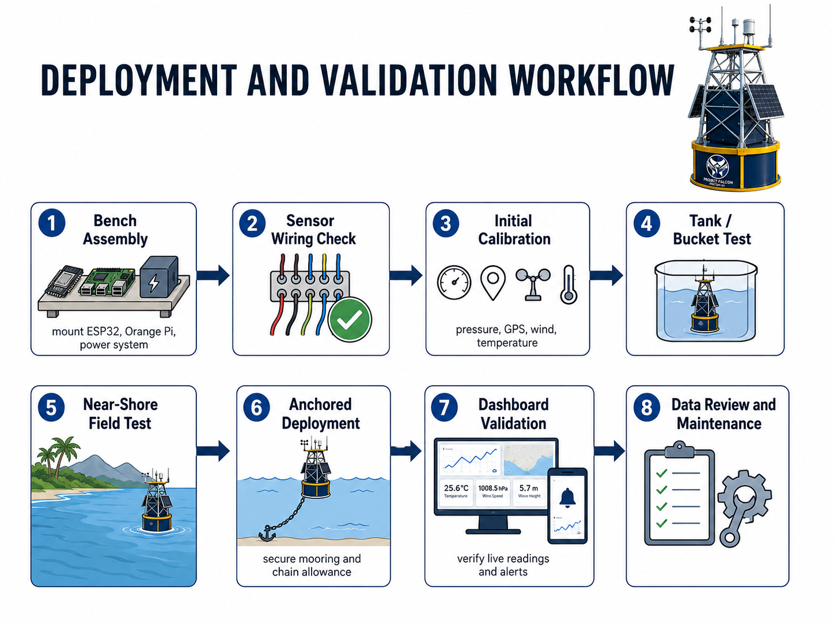
Figure 6. Detailed deployment, calibration, validation, and maintenance workflow.

26. System Flow Summary
The following concise flow should be used consistently in presentations, diagrams, and implementation notes:
Sensors → ESP32 acquisition/validation → USB serial/UART → Orange Pi local processing/storage/API → local dashboard → user. The saved FALCON Assistant is currently disabled; if re-enabled, it may consume validated system state but shall never control or replace the core monitoring pipeline.

27. Design Decisions Requiring Final Adviser Approval
The following items remain intentionally unresolved and should not be treated as final until exact hardware, datasheets, fabrication constraints, and controlled tests are available: exact GPS model; exact wind-speed and wind-direction sensor models; tamper sensor type; enclosure switch and buzzer electrical ratings; pressure-sensor mounting depth; solar-panel rating; MPPT model; battery capacity; converter and fuse ratings; final PCB connectors and pinout; mooring line material/length/scope; and the independent wave-reference method.

Appendix A — Approved Telemetry Sections
• system
• wave
• environment
• gps
• power
• security
• health
• assistant
• alerts

Appendix B — Immediate Documentation Records Required
• Exact component and supplier register
• Sensor calibration sheets
• Pressure installation-depth and baseline record
• GPS geofence configuration and test record
• Tamper/enclosure debounce and false-alert record
• Power-load and autonomy worksheet
• Waterproofing and pre-deployment checklist
• Controlled-test dataset and analysis
• Dashboard usability/readability test record for non-technical users
• Pressure-sensor mounting-depth, bracket, and reference-validation record

